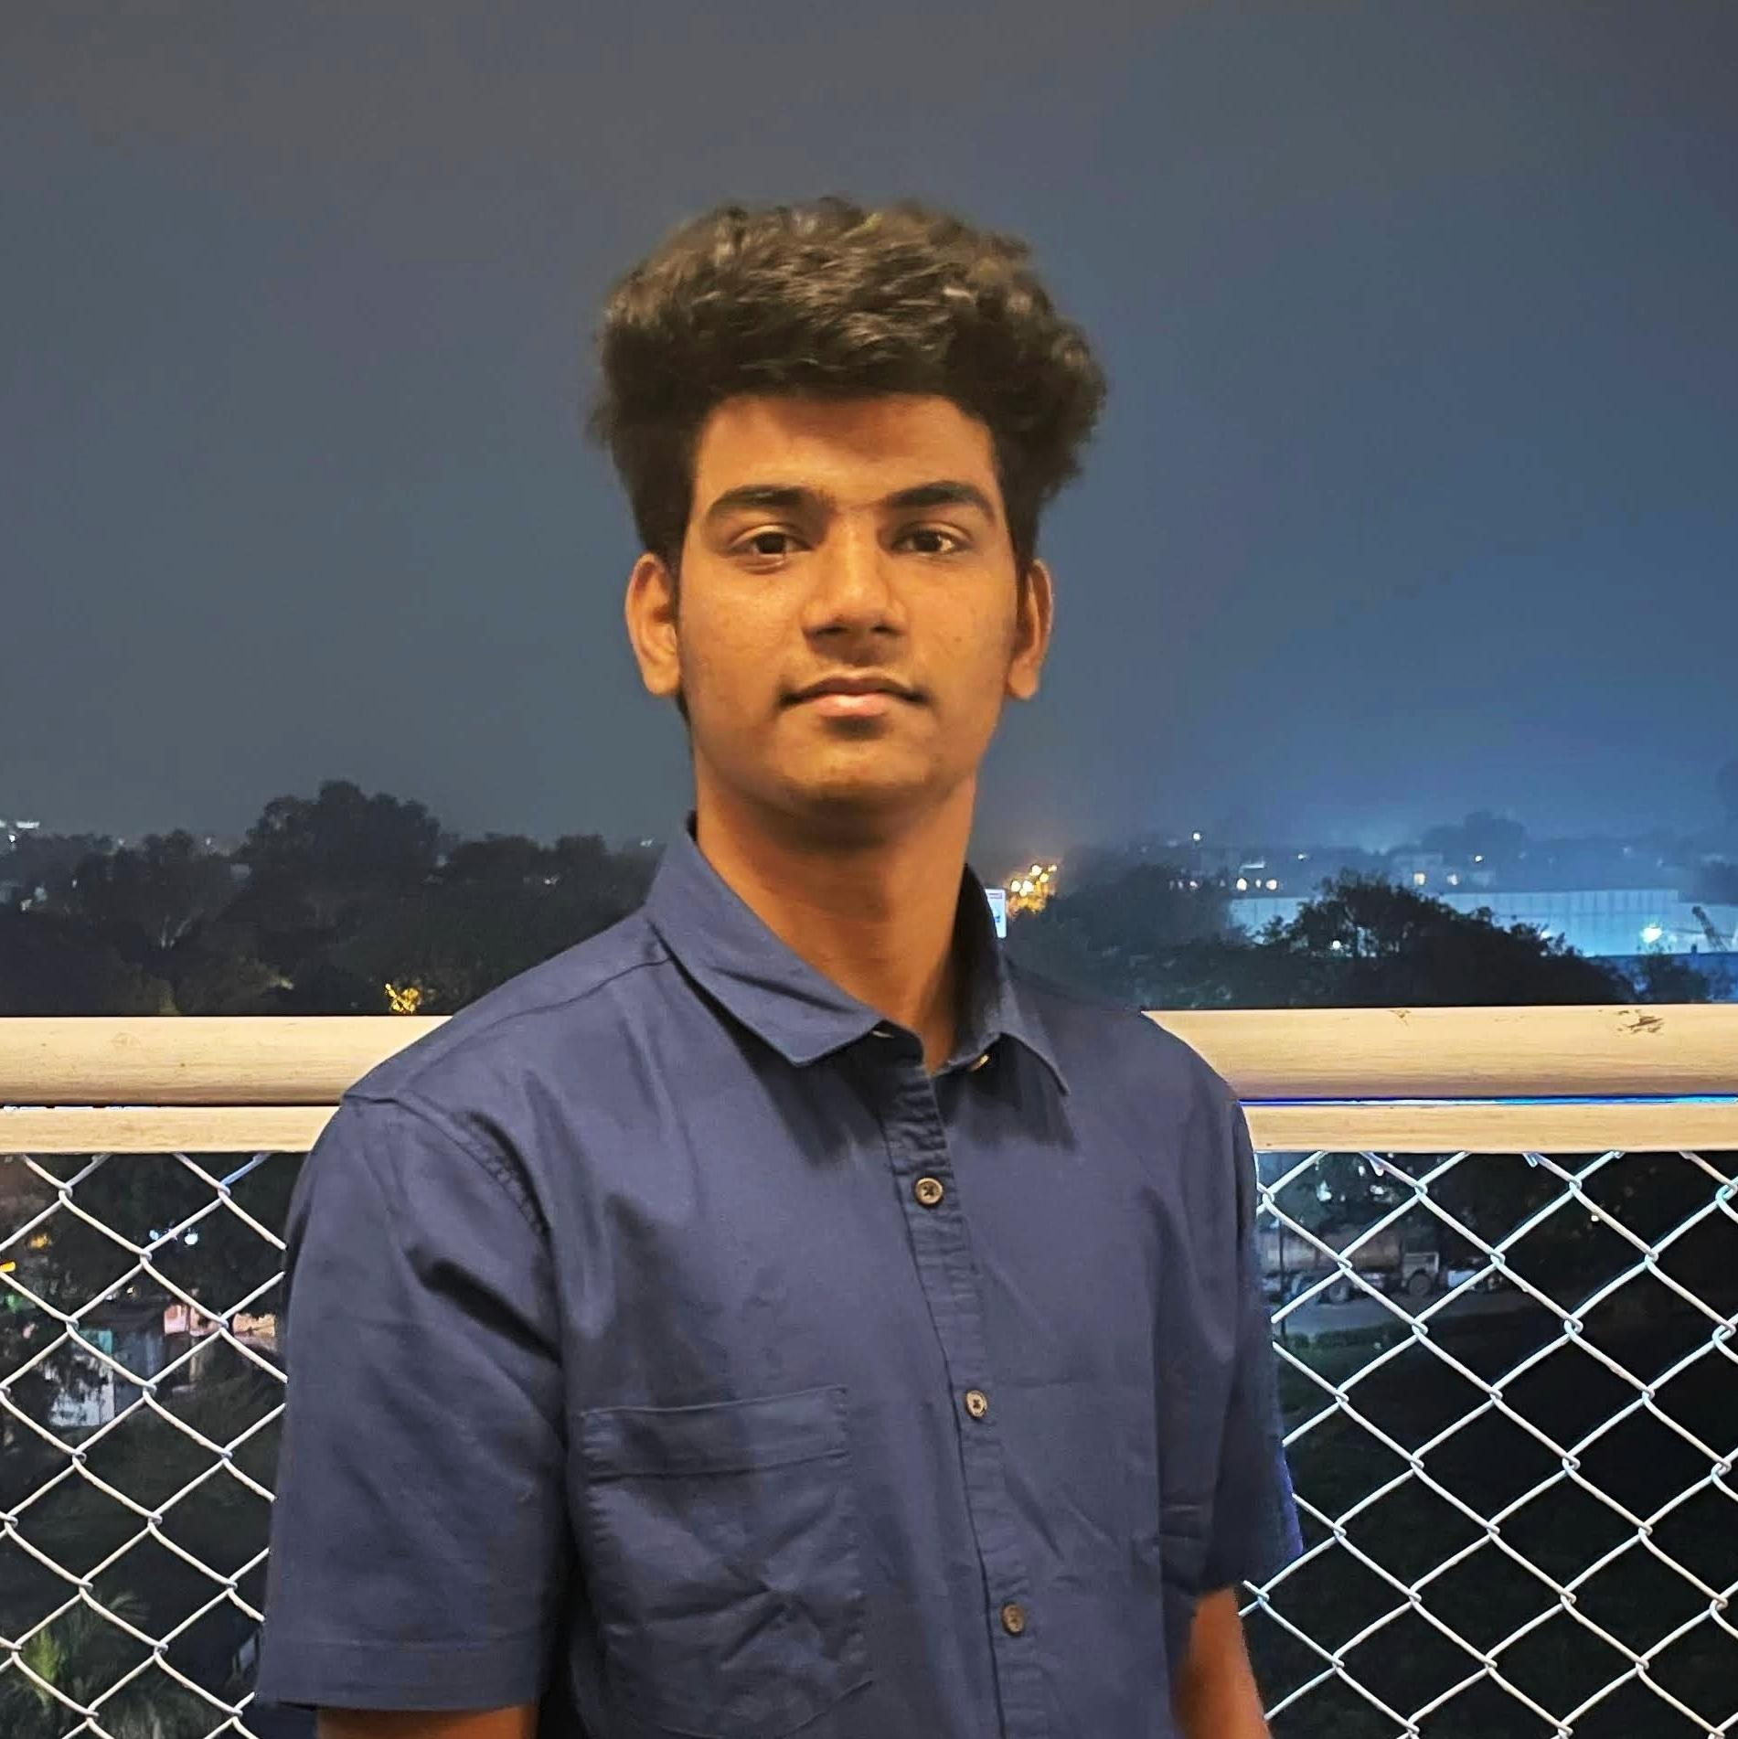

| **Vishnu Vardhan**  2020480, Email: [vishnu20480@iiitd.ac.in](mailto:vishnu20480@iiitd.ac.in) |
| --- |
| DOB: Feb 24, 2003 |
| Address: Hyderabad, Telangana, India  [LinkedIn](https://www.linkedin.com/in/vish24vishnu/) | [GitHub](https://github.com/V15hnu24) | [Website](https://my-project-2168c.web.app/) |
|  |

| **Education** |
| --- |

| **Indraprastha Institute of Information technology, Delhi**  B.Tech (CSE + Social Sciences)  2020 – Present | CGPA: 7.45  (IVthSemester) |
| --- | --- |
|  |  |
| **Narayana Junior College, Hyderabad India**  Telangana State Board of Intermediate Education  2018 – 2020 | Percentage: 92 |
| **Gowtham Model School, Hyderabad India**  Telangana State Board of Secondary Education  2020 | CGPA: 9.3 |

| **Skills** |
| --- |

| **Expertise Area** | Problem Solving, Data Structure and Algorithms, Software Development |
| --- | --- |
| **Programming**  **Language** | Java, Python, SQL, JavaScript, Node JS, R, HTML, CSS, C, Bash, Flask |
| **Tools and**  **Technologies** | JavaFX, Express JS, Python Pandas, MySQL, MongoDB, Git, Bootstrap, [GitHub](https://github.com/V15hnu24) |
| **Technical Electives** | Data Structure and Algorithm, Database Management Systems, Advance Algorithm and Analysis, Computer Organization, Probability and Statistics, Operating System, Discrete Mathematics, Linear Algebra, Econometrics, Convex Optimization. |

| **Experience** |
| --- |

| Outreach lead and Business Strategy at Memboro  [Memboro](https://memboro.com/), Delhi India   * Leading the outreach team, working on strategizing efficient ways to reach out and onboard Content Creators and social media influencers, and working on business strategy and operations.   Creator Acquisition (Outreach) at Memboro  [Memboro](https://memboro.com/), Delhi India | June 22 - Present  Team Size - 4  Jul 21 – May 22 |
| --- | --- |
| * Built good public relations for the company, found new ways to contact people, and convinced them to join Memboro. | |
| Co-Founder of Passious  [Passious](https://passious-two.vercel.app/), Delhi India | Mar 22 – April 22 |

* Built good foundations for the startup and reviewed the development of **Mobile application and Website.** Helped in Strategizing the outreach and Marketing.

| **Projects** |
| --- |

**Portfolio Website |** [**Link**](https://my-project-2168c.web.app/) **|** [**Github**](https://github.com/V15hnu24/Vishnu-portfolio-website)  May 22

* Developed Portfolio website using HTML, CSS, JavaScript, Bootstrap for frontend and ExpressJs, NodeJS, and MongoDB for Backend.

| **Regression Models |** [**GitHub**](https://github.com/V15hnu24/Regression) | Mar 22 – April 22  Team size - 5 |
| --- | --- |
| * Found the relation between health indicators such as the percentage of children demised from fever and data like agricultural conditions, and tap water facilities for all districts of India. * Cleaned and filtered huge data using **R, Python Pandas**, and **MS-EXCEL** techniques. Found the relation using Regression models, and visualized and analyzed the data relations using histograms.   **Backend for E-commerce website** Mar 22 - April 22  Team size - 4   * Created fully functional backend and dababase for an Ecommerce website using RDBMS, MYSQL, Flask, HTML, CSS, JavaScript. * Currently working on Front-end of the platform and making it fully functional. | |
| **Will Hero |** [**GitHub**](https://github.com/V15hnu24/Will-Hero-AP-)plementation of the existing cross-platform game Will   * An Implementation of the existing cross-platform game Will Hero using **Java**, **OOPS**, **JavaFX**, **CSS.** | Dec 2021  Team Size – 2 |
|  |  |
|  | |
| **Positions of Responsibility** | |

| * Board Member Entrepreneurship Cell IIIT Delhi * Part of Salt N Pepper club IIIT Delhi * Ninja Entrepreneur Coding Ninjas | Jul 21 – Present  Jan 22 - April 22  Dec 21 – Mar 22 |
| --- | --- |

| **Awards and Achievements** |
| --- |

* Earned 3x of investment through affiliate marketing for a stock trading platform in 45 days (May 21 – Jun 21)

| **Interests and Hobbies** |
| --- |

| * Badminton * Reading about new technologies. |
| --- |
| * Reading and watching business and political news |

Declaration: The above information is correct to the best of my knowledge.

Vishnu Vardhan

Date: June 21, 2022